**Email Configuration**

**Purpose of this document**

This document narrates the set-up and functionality behind the servers used in the Smart Touch application for sending emails and text messages to the users as a part of marketing and alerts.

**Configuration Providers**

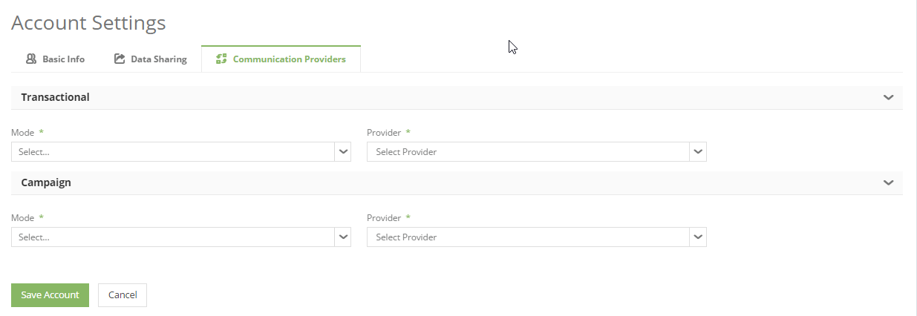

Figure : Interface Snapshot

Configuration providers are categorized as two types namely –

* Sending Emails Alerts
* Sending Text Alerts

The functionality undertaken by the configuration providers, in simple terms can be compared with a postman. Wherein the postman plays a role in delivering the mail from one person to another. The configuration providers help in the communication of the alerts for following at an account level –

**Contacts Module:** Add Action; Add Tour; Send Email; Send Text

**Campaigns Module:** Sending Campaigns

As per the above category, in Smart Touch, the email configuration set-up is handled by either VMTA or Mail Chimp. The text message configuration is handled by Twillio.

Both the configurations shall be done by the ST Super Administrator for the specific accounts as per the subscription. The ‘Communication Providers’ tab is only available for the Account Administrator in the Account Settings window.

**Email Configuration Providers**

Email configuration providers for **‘Transactional’** are as follows –

**Send Grid:** Accounts configured with Send Grid shall see the following screen along with the options related to it. The set-up for the account(s) that are subscribed with this service shall be done by the ST Super Administrator. The set-up related information for an account, shall be editable to the account administrator. This configuration is to support the communication actions related to the contacts grid namely - Add Action; Add Tour; Send Email.

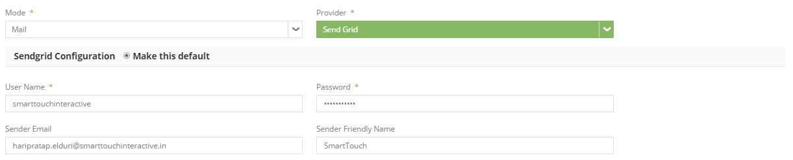

The email configuration providers for **‘Campaign’** are as follows –

**VMTA:** Accounts configured with VMTA shall see the following screen along with the options related to VMTA. The set-up for the account(s) that are subscribed with this service shall be done by the ST Super Administrator. The set-up related information for an account, shall be viewable and not editable to the account administrator.

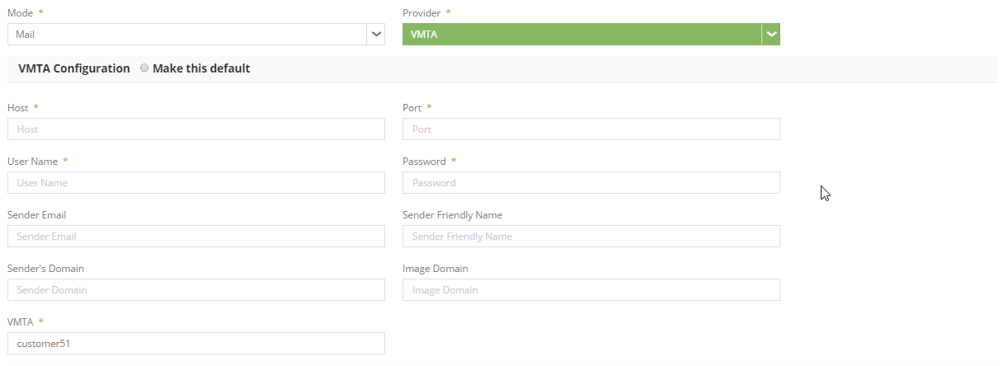

**MailChimp:** Accounts configured with MailChimp shall see the following screen along with the options related to it. The set-up for the account(s) that are subscribed with this service shall be done by the ST Super Administrator. The set-up related information for an account, shall be editable to the account administrator.

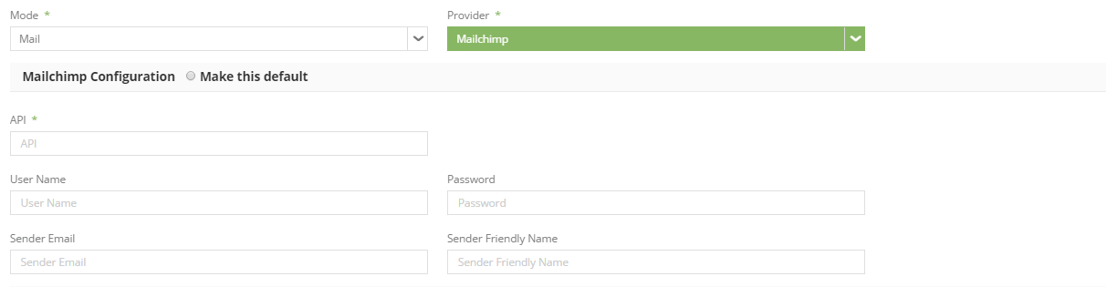

**Text Configuration Providers**

**Twillio:** Accounts configured with Twillio shall see the following screen along with the options related to it. The set-up for the account(s) that are subscribed with this service shall be done by the ST Super Administrator. The set-up related information for an account, shall be editable to the account administrator.

This configuration is only available for ‘Transactional’ as a text communication provider. This configuration is to support the communication actions related to the contacts grid namely - Send Text.

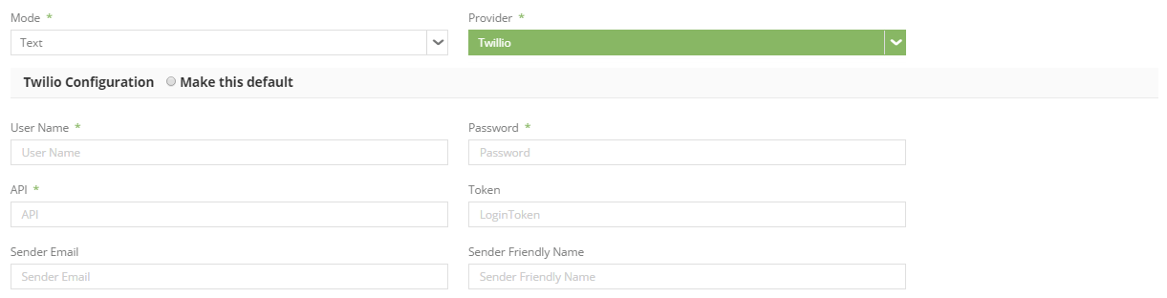

**Field Level Validations**

| **Name** | **Type** | **Mandatory** | **Description** | **Values/Options** |
| --- | --- | --- | --- | --- |
| **Transactional and Campaign** | | | | |
| Mode | Dropdown | Yes | This is a dropdown field that shall list the options pertaining to the mode of communication. | Transactional: Mode = Mail; Text Campaign: Mode = Mail |
| Provider | Dropdown | Yes | This is a dropdown field that shall list the service provider(s) related to the mode of communication that is selected. | If the mode selected is Mail: Select [default] Send Grid VMTA Mail Chimp If the mode selected is Text: Select [default] Twillio |
| **[Mode = Mail]** | | | | |
| **VMTA Configuration** | | | | |
| Host | Free Text | Yes | This is a free text field to capture the host details. | This field appears when the mode selection is mail. |
| Port | Free Text | Yes | This is a free text field to capture the port details. | This field appears when the mode selection is mail. |
| User Name | Free Text | Yes | This is a free text field to capture the host username. | This field appears when the mode selection is mail. |
| Password | Free Text | Yes | This is a free text field to capture the host password. | This field appears when the mode selection is mail. |
| Sender Email | Free Text | No | This is a free text field to capture the email address of the sender through which the email is triggered. | This field appears when the mode selection is mail. |
| Sender Friendly Name | Free Text | No | This is a free text field to capture the name of the sender through which the email is triggered. | This field appears when the mode selection is mail. |
| Sender's Domain | Free Text | No | This is a free text field to capture the domain details of the sender. | This field appears when the mode selection is mail. |
| Image Domain | Free Text | No | This is a free text field to capture the image domain details of the sender. | This field appears when the mode selection is mail. |
| VMTA | Free Text | Yes | This is a free text field to capture the VMTA id. | This field appears when the mode selection is mail. |
| **Send Grid - This option should be available only under Transactional when the Mode is selected as Mail.** | | | | |
| User Name | Free Text | Yes | This is a free text field to capture the host username. | This field appears when the mode selection is mail. |
| Password | Free Text | Yes | This is a free text field to capture the host password. | This field appears when the mode selection is mail. |
| Sender Email | Free Text | No | This is a free text field to capture the email address of the sender through which the email is triggered. | This field appears when the mode selection is mail. |
| Sender Friendly Name | Free Text | No | This is a free text field to capture the name of the sender through which the email is triggered. | This field appears when the mode selection is mail. |
| **MailChimp** | | | | |
| API | Free Text | Yes | This is a free text area to capture the API details regarding mail chimp. | This field appears when the mode selection is mail. |
| User Name | Free Text | No | This is a free text field to capture the host username. | This field appears when the mode selection is mail. |
| Password | Free Text | No | This is a free text field to capture the host password. | This field appears when the mode selection is mail. |
| Sender Email | Free Text | No | This is a free text field to capture the email address of the sender through which the email is triggered. | This field appears when the mode selection is mail. |
| Sender Friendly Name | Free Text | No | This is a free text field to capture the name of the sender through which the email is triggered. | This field appears when the mode selection is mail. |
| **[Mode = Text] Only applicable for Transactional and not for Campaigns** | | | | |
| **Twillio Configuration** | | | | |
| User Name | Free Text | No | This is a free text field to capture the host username. | This field appears when the mode selection is text. |
| Password | Free Text | No | This is a free text field to capture the host password. | This field appears when the mode selection is text. |
| API | Free Text | Yes | This is a free text area to capture the API details regarding mail chimp. | This field appears when the mode selection is text. |
| Token | Free Text | No | This is a free text area to specify the token details for the Twillio server to communicate with the application in order to send text alerts. | This field appears when the mode selection is text. |
| Sender Email | Free Text | No | This is a free text field to capture the email address of the sender through which the email is triggered. | This field appears when the mode selection is text. |
| Sender Friendly Name | Free Text | No | This is a free text field to capture the name of the sender through which the email is triggered. | This field appears when the mode selection is text. |

**General Assumptions and Use Cases**

1. The following are the options that are available under ‘Transactional’:-
2. Transactional – When the ‘Mode’ is selected as ‘Text’, ‘Twillio’ shall default as the ‘Provider’.
3. Transactional – When the Mode’ is selected as ‘Mail’, ‘Send Grid’ shall default as the ‘Provider’.
4. The following are the options that are available under ‘Campaign’:-
5. Campaign – The only option that is available under ‘Mode’ is ‘Mail’ and the related options for ‘Provider’ are ‘MailChimp’ and ‘VMTA’.
6. An account can be subscribed to both – MailChimp and VMTA and can have one of them as default by selecting ‘Make this default’ option.
7. The ‘Sender Email’ shall populate as the first email id in the ‘From’ dropdown, for every campaign created under the account along with the email ids of the logged in user. In case the selection is made in the ‘From’ dropdown of the campaign form, the value selected here shall take the precedence.
8. The ‘Sender Friendly Name’ shall populate in the free text in the ‘Sender Name’, for every campaign created under the account. In case a name is specified in the ‘Sender Name’ field of the campaign form, the value selected here shall take the precedence.

